Proceedings of the
2021 Annual Conference

Great Lakes Academy
of Legal Studies in Business

October 22, 2021
Virtual via Zoom

Great Lakes Academy of Legal Studies in Business

Table of Contents

I. Conference Schedule 2

II. Presentation Abstracts 4

III. Papers Published in Proceedings 7

  - Business Law Professors Contribute to Business School Accreditation 8
Catherine Jones-Rikkers, Grand Valley State University
James Sanford, Grand Valley State University

  - Deductibility of Business Expenses – Clear Language or Convoluted Meaning? 15
A Teaching Moment in an Undergraduate Federal Tax Course
Joseph J. Galante, CFE

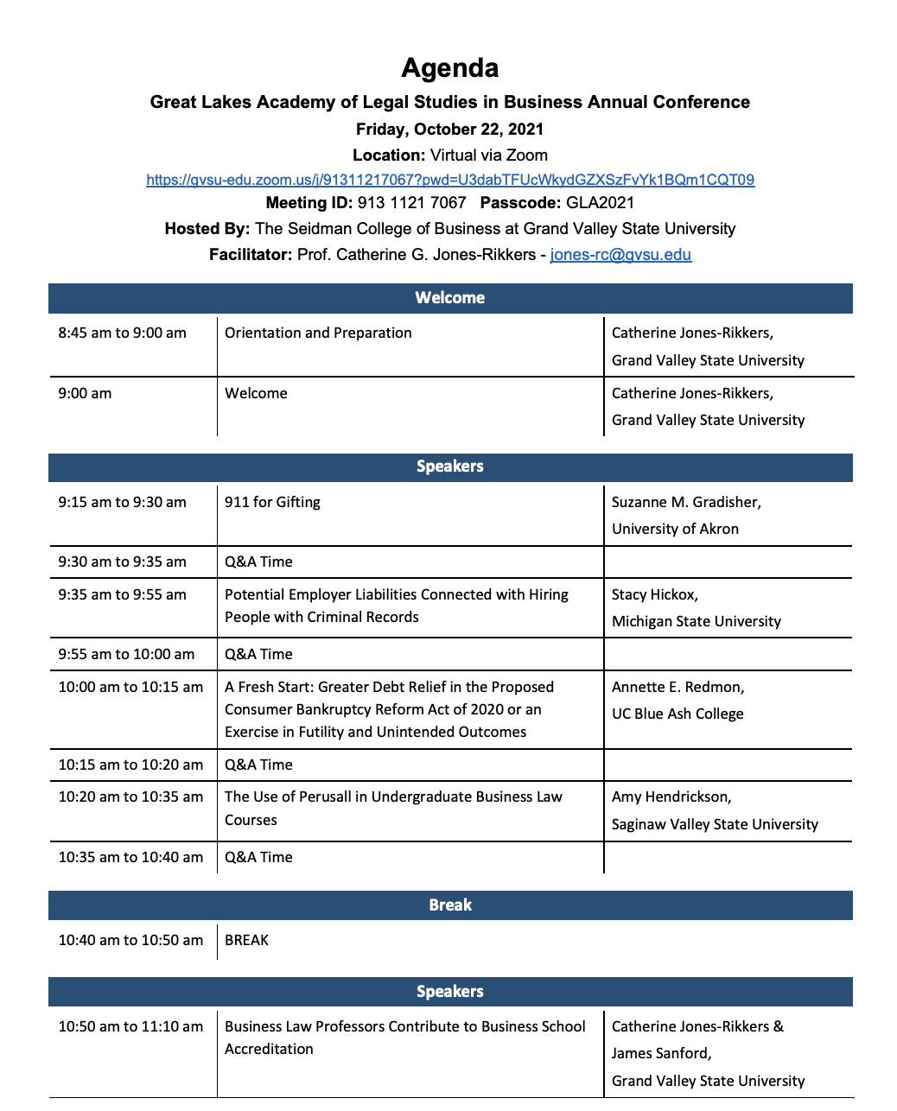
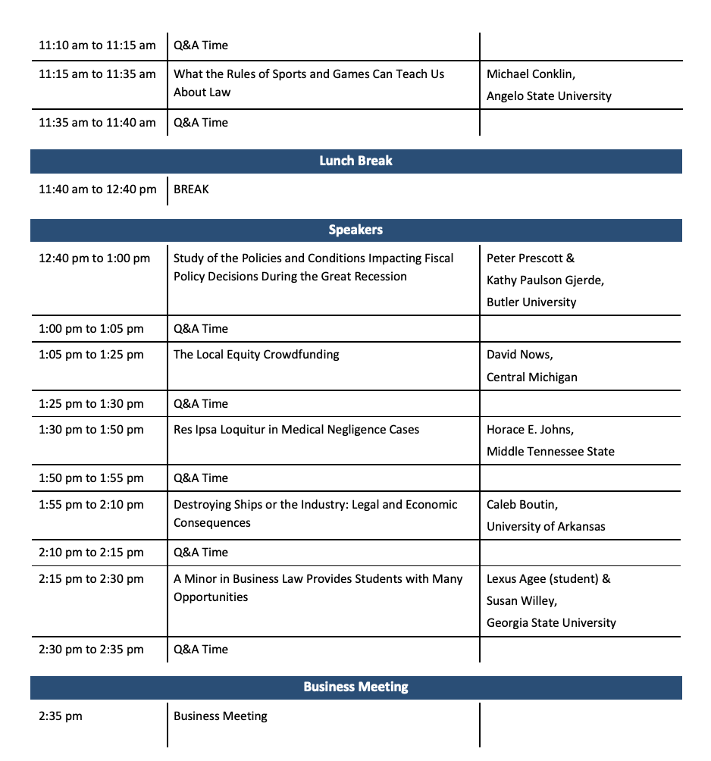
Great Lakes Academy of Legal Studies in Business

Presentation Abstracts
(Alphabetized by first presenter’s last name)

Lexus Agee, Georgia State University
Susan Willey, Georgia State University
College to Career: How a Minor in Business Law Prepares Students for a Variety of Careers that Don’t Require a Law Degree

A minor in Business Law provides students with opportunities to develop and improve their communication, problem-solving, critical thinking, and time management skills, as well as their ability to collaborate effectively and creatively – soft skills employers complain undergraduate students often lack when they enter the work force. This paper describes the College to Career initiative at Georgia State University, which stresses the acquisition and transferability of career readiness competencies and skills, before exploring several law-related career options in risk management, insurance, finance, human resources, marketing, and other business disciplines where a minor in Business Law would be beneficial. We will also demonstrate the Stepping Blocks tool available to GSU undergraduates that they can use to explore job opportunities and career pathways related to the Business Law Minor.

Michael Conklin, Angelo State University
What the Rules of Sports and Games Can Teach Us About Law

The explicit premise of this presentation is that sports and competitive games are legal systems. Therefore, inquiries into their jurisprudential aspects prove highly beneficial, just as in every other area of law. The presentation is, in a sense, a study in comparative law. As this presentation demonstrates, the insights covered are a valuable resource for Legal Environment professors looking to create engaging classroom illustrations.

Suzanne Gradisher, University of Akron
911 for Gifting

The successful financial/estate plan will often include gifting strategies that minimize taxes, maximize flexibility, and considering the current political environment, considers future tax law changes. This article provides an overview of the current gift tax law and insight into many of the changes proposed by the current administration. It concludes with a discussion of how the proposals impact life insurance trust planning.

Amy Hendrickson, Saginaw Valley State University
Use of Perusall in Undergraduate Business Law Courses

The use of the social annotation tool Perusall in undergraduate business law courses creates a variety of flexible approaches to reading assignments, class discussions, and group projects. The flexibility is particularly valuable during the current period when pandemic related restrictions may require rapid changes to teaching modes, with accommodation for students who are able to participate but not attend traditional classes.

With unexpected expenses affecting both student and institutional budgets, it is important to note that this tool can be used with no incremental cost to the institution and is well suited to the use of primary documents like court decisions and government publications.
This presentation will explore the flexible, cost-effective use of Perusall in undergraduate law courses, as well as providing some initial information regarding the impact of this tool on educational outcomes.

Stacy Hickox, Michigan State University
Potential Employer Liabilities connected with Hiring People with Criminal Records

People with a criminal record face challenges in finding and retaining employment, in large part because of the gap between employer preferences and the perceived qualifications of applicants with a criminal record. Original surveys of employers and interviews with people with a criminal record help us understand what is creating such barriers for applicants with a criminal record. The paper analyzes responses from employers surveyed on their perspective and attitudes about the hiring of people with a criminal record and the responses of people with a criminal record regarding their experience and perspective in applying for jobs within Michigan. These responses will be analyzed in light of legal research regarding disparate impact of employers’ consideration of applicants’ criminal records and current standards to impose liability for the negligent hiring of people with a criminal record.

Catherine G. Jones-Rikkers, Grand Valley State University
James Sanford, Grand Valley State University
Business Law Professors Contribute to Business School Accreditation

Business Law / Legal Environment professors have an important new role to play in contributing to their business schools. AACSB Standard Number 9 provides that the business school must demonstrate positive societal impact through internal and external initiatives. The interpretive guidelines suggest several ways to meet this standard. This paper will discuss how the Seidman College of Business, host of the Great Lakes Academy of Legal Studies in Business Annual Conference, Fall 2021, has approached Standard 9 for its current accreditation review and how the Business Law professors have helped in this effort.

David Nows, Central Michigan University
The Local Nature of Equity Crowdfunding

Current scholarship portrays equity crowdfunding as a disaster. Many experts say that only startups that cannot utilize more traditional methods of financing will turn to equity crowdfunding. Additionally, given that the only ventures using equity crowdfunding are otherwise unworthy of funding, those startups make for incredibly risky investment opportunities. Further, unaccredited investors (investors with lower incomes and net worth) regularly participate in these risky offerings, creating the potential for investors that cannot afford to lose their investments entering into investments that they are very likely to lose. Critics claim that this perfect storm makes equity crowdfunding undesirable. This article seeks to reverse that narrative by considering equity crowdfunding issuers previously ignored by the scholarly literature: businesses in the arts, entertainment, and sports industries with an intense local following. A closer look at these equity crowdfunding campaigns reveals that these ventures have found success when raising money from local “fans” who engage with the entertainment experience provided by the business. This article also argues that we should re-frame scholarly discussions around equity crowdfunding and advocates for common-sense reforms to Regulation Crowdfunding to make it easier for companies to raise money from their fans, while maintaining strong investor protections.

Peter Prescott, Butler University
Kathy Paulson Gjerde, Butler University
The Impact of State Fiscal Policy on States’ Resilience During the Great Recession

This study examines policies and conditions in the United States that impacted the length and depth of the Great Recession at the state level. In general, we found that the states’ fiscal-policy decisions leading up to the Great Recession had little or no effect on its duration, but that the relative magnitude and mix of fiscal policy instruments the states employed did affect that recession’s depth for each state. Furthermore, our results suggest that states can have a meaningful impact on recession length and depth by engaging in certain types of long-term structural planning. These findings help explain the states’ differing ability to navigate economic shocks, like the Great Recession, and that knowledge may aid state governments when they confront future recessionary events.

Annette E. Redmon, University of Cincinnati - UC Blue Ash College
A Fresh Start: Greater Debt Relief in the Proposed Consumer Bankruptcy Reform Act of 2020 or an Exercise in Futility and Unintended Outcomes

The Consumer Bankruptcy Reform Act of 2020 proposed significant reforms to consumer bankruptcy law. The unpassed bill proposed new standards for eligibility for discharge of debt, including debt ceilings and homestead exemption. Moreover, the proposal included new types of debt not previously dischargeable in bankruptcy, including student loan debt forgiveness. The bill also establishes consumer bankruptcy protections, including the creation of a Consumer Bankruptcy Ombuds at the Consumer Financial Protection Bureau. While the legislation was not adopted in the 116th Congress, many of these provisions are likely to be proposed with the new Congress and administration. This presentation will​ highlight several proposed changes and evaluate the potential effects of the proposed changes for debt relief for individual consumers and the economic costs of these proposals to businesses and taxpayers accordingly.

Great Lakes Academy of Legal Studies in Business
Papers Published in the Proceedings

Business Law Professors Contribute to Business School Accreditation 8
Catherine Jones-Rikkers, Grand Valley State University
James Sanford, Grand Valley State University

Deductibility of Business Expenses – Clear Language or Convoluted Meaning? 15
A Teaching Moment in an Undergraduate Federal Tax Course
Joseph J. Galante, CFE

Business Law Professors Contribute to Business School Accreditation

By

Catherine G. Jones-Rikkers*

And

James Sanford**

Abstract

Business Law / Legal Environment professors have an important new role to play in contributing to their business schools. AACSB Standard Number 9 provides that the business school must demonstrate positive societal impact through internal and external initiatives. The interpretive guidelines suggest several ways to meet this standard. This paper will discuss how the Seidman College of Business, host of the Great Lakes Academy of Legal Studies in Business Annual Conference, Fall 2021, has approached Standard 9 for its current accreditation review and how the Business Law professors have helped in this effort.

Introduction
The Association to Advance Collegiate Schools of Business (AACSB), is a global nonprofit association. According to its website, the AACSB seeks “…to connect educators, students, and business to achieve a common goal: to create the next generation of great leaders.” Created in 1916, the AACSB provides quality assurance, business education intelligence, and learning and development services to over 1,700 member organizations and more than 900 accredited business schools worldwide. The AACSB’s mission is to foster engagement, accelerate innovation, and amplify impact in business education.
In late July of 2020, the AACSB announced a renewed commitment and focus on creating positive societal change. Their new standards, which were updated in the summer of 2021, emphasize that AACSB accredited schools should be a force for good in society. This ideal was included as a core component in the new Standard 9 of the AACSB’s Business Accreditation Standards.
“Standard 9” as it’s now known, requires that an accredited program show engagement and societal impact and that the school “…demonstrates positive societal impact through internal and external initiatives and/or activities, consistent with the school’s mission, strategies, and expected outcomes.”

Standard 9: Engagement and Societal Impact

The AACSB has issued interpretive guidance as to how business schools might address this standard. The overall goal is to show how the activities of the business school make a difference in helping business be a force for good and have societal impact in the external world. Business schools need to articulate the impact of the school’s activities and describe aspirations and plans for the future. “The emphasis in this standard is on engagement by schools with external stakeholders that lead to societal impact.” The scope of a school’s activities can be divided into internal and external. For example, internal activities might include the business school having solar panels or a green certified building. External activities include all activities where the school engages with external stakeholders in a way that makes a positive societal impact. For example, student projects that undertake social or environmental service roles with external stakeholders that lead to positive societal impact would help the school achieve the standard.

Other examples of external impact include showing how the business school contributes and has impact on the local, regional, or national economy, how the school has a positive impact on human rights, how the school helps with business development, and how the school has a positive impact on the health and safety of external business. Overall, the standard allows schools wide discretion as to how to show a positive societal impact.

“It is expected that over time the degree of impact by the school will increase; a wider range of the school’s activities will have an impact; the impact will come from a range of departments, centers, programs, and disciplines; and a growing proportion of students will be involved in initiatives and activities that have societal impact.” All of this will need to be documented, assessed, and adjusted for future progress.

The Seidman College of Business Plan and the Role of Business Law Professors

The Seidman College of Business, as a starting point to facilitate discussion and to establish a framework for future development on AACSB Standard 9, identified the 17 United Nations Sustainable Development Goals (“SDGs”) and documented Seidman’s past and current societal impact activity related to these SDGs. The following is an example of the contribution by Seidman business law professors toward some of these goals.

U.N. SDG #5 – Gender Equity: Seidman professors cover this topic in their Legal Environment of Business course when discussing employment law, workplace discrimination and business ethics.

U.N. SDG #6 – Clean Water and Sanitation: When covering business organizations, environmental regulation and ethics, business law professors discuss local businesses that dumped PFAS’s (man-made “forever” chemicals that don’t break-down and are dangerous to the environment and human health) into local ground areas without proper protection. In turn these chemicals have been found in the drinking water in homes as well as local groundwater, lakes, and streams.

U.N. SDG #10 – Reduced Inequalities: Class discussions involving the subjects of compliance with employment laws, anti-discrimination provisions in the U.S. Constitution and ethics cover topics in this area.

U.N. SDG #11 – Sustainable Cities and Communities, U.N. SDG #13 – Climate Action and
U.N. SDG. #16 – Peace, Justice, and Strong Institutions: These SDGs are covered in the Legal Environment of business class through a variety of topics. The history of the sustainability movement is discussed starting with the first United Nations Conference on Environment and Development, also known as the 1992 Rio de Janeiro Earth Summit. Expanded subjects include the concepts of the triple-bottom-line reporting and the current Business Roundtable statement on the new purpose of the corporation. Enlightened managers of corporations no longer manage to maximize profits for the shareholders but manage to consider all stakeholders, including the society at large. The growing recognition of B-Corp’s is examined. Corporate Social Responsibility (CSR) has a business strategy is emphasized. Many customers and students want to do business with environmentally friendly businesses that practice the triple-bottom-line like B-Corp’s. As these examples show, the current business law class not only discusses the legal environment of business but has expanded to show students how business can be a force for good and have a positive societal impact.

U.N. SDG #17 – Partnerships for the Goals: The Seidman College also has extensive outreach in the local and regional economy with various outreach centers. “These centers each focus on different segments of Michigan’s economy. They also engage with academic units through student projects, hiring interns, and making some of their programs available to students. Their activities contribute strongly to the service component of the Seidman and GVSU mission.”
The outreach centers include the following:
Small Business Development Center (SBDC) – Lead Center and West Michigan Regional Center
Van Andel Global Trade Center (VAGTC)
Family-Owned Business Institute (FOBI)
The Richard and Helen DeVos Center for Entrepreneurship and Innovation (CEI)
Koeze Business Ethics Initiative (KEBI)
The outreach centers provide business law professors additional opportunities to further contribute to the school’s community involvement through research and presentations, consulting, leading seminars, and assisting students with various community projects.

Through the implementation of Standard 9 plans which include Legal Environment / Business Law classes, students become educated about how not only business can be a force for good, but how they themselves can become such a force. This sort of education, engagement and understanding is critical for the success of the business and the future of the world.

Future Work in the area of Societal Impact – Getting Involved

Since Standard 9 is fairly new (effective July 2020, updated July 1, 2021), most business schools are just starting to organize an approach to meeting this standard. This provides business law professors a chance to get involved with how this standard will be addressed at their school. For example, at Seidman, “A formal framework for activities related to societal impact will be developed as part of the 2021-26 strategic plan. Using the College Wide Meeting structure for developing and evaluating actions related to strategic priorities, strategic goals and actions for the next five years will be identified. The United Nations Sustainable Development 17 Goals will be used as a foundation for framework development.” This framework in turn allows for the legal environment/business law educators to carve out their place in helping the institution to maintain its AACSB accreditation.

Conclusion

This is an exciting time for business law professors as we contribute to the education of our students. The forward-looking professor of business law can help their institutions become a force for good, by educating students on ways to engage in their world positively and meaningfully. Antidotal evidence suggests that students seek to make meaningful contributions in their professional and personal lives. As discussed in this article, the business law classroom provides numerous opportunities for students to learn about engaging in their communities and to in turn become a force for good as they take on leadership roles after graduation. There is little doubt that these enlightened leaders can and will be a force for good. Those of us who teach business law make a valuable contribution toward reaching the goals set by Standard 9 and in turn can ourselves be an engaged force for good in society.

Deductibility of Business Expenses – Clear Language or Convoluted Meaning?

A Teaching Moment in an Undergraduate Federal Tax Course

By

Joseph J. Galante, CFE
Professor of Accounting, Taxation, and Law
Lombardo College of Business
Department of Accounting and Finance
Millersville University of Pennsylvania
Millersville, PA

joseph.galante@millersville.edu

717-871-7167

In general, federal taxation topics may seem uniform; however, key qualitative issues inherent in the Internal Revenue Code (“Code”) and the United States Treasury Regulations (“Regs”) can impact business decisions, and operational strategies. These issues cannot be quantified nor proscribed. Nonetheless, reading the Code and the Regs may appear to be clear and to the point. However, there are hidden concerns and subtle nuances that cannot be ignored.

These concerns and nuances surface in the practical and operational function of tax planning and are found in the Code and Regs and become evident in operational practices – i.e., the “operational expectation gap.” This operational expectation gap provides an excellent scenario for analysis, discussion, and critical thinking in an undergraduate federal taxation course. The course professor has a wide breadth of topical tax, and accounting-related issues to discuss and analyze in the classroom conversation.

Similar to other non-tax laws found in various business settings, there is ample discretion for having a different perspective on certain federal tax topics. The discretion addressed in this writing is coming from the Revenue Agent in the scope of an Internal Revenue Service (“IRS”) tax examination – i.e., the tax audit.

Once such topical area concerns the deductibility of business expenses. The following scenario is adapted from a tax examination conducted by the author when employed by the IRS as a Revenue Agent in the Manhattan District Office, located in New York City.

This scenario addresses the operational expectation gap between what the law reads and how it is applied (or applied differently) in practice. While qualitative in nature, this scenario illustrates the importance of understanding and appreciating how and when to exercise judicial use of interpretative reading.

The basic law school “IRAC” methodology shall be used in the classroom analysis and discussion. The scenario has been simplified for classroom purposes; it includes the pertinent information relative to the issue at hand.

ISSUE: The Deductibility of Business Expenses.
RULE of LAW: An individual, corporation, partnership, trust, or estate generally may deduct from gross income the ordinary and necessary expenses of carrying on a trade or business that are paid or incurred during the tax year (Code Sec. 162; Reg. §1.162-1).
APPLICATION: Requires researching the meaning of “ordinary and necessary” in the examination process based upon the specifics of the taxpayer’s filed return.
CONCLUSION: Strict constructionist viewpoint from the Revenue Agent or a more flexible interpretation of the Code and Regs?

A. FACT PATTERN:
- A medical professional corporation owned and operated by three highly regarded board-certified medical doctors practicing ophthalmology in a suburban New York City location.
- The corporation’s two prior years’ tax returns are under examination.
- Neither the corporation nor the individual doctors have ever been audited by the IRS before this.
- The corporate stock is divided by 33% for each doctor with 1% to a neutral-detached third party in case of any decisions resulting in stalemates, deadlocks, etc.
- The corporation owns the following major assets:
- Medical Building and Parking Lot
- Medical Equipment including furniture and fixtures
- Three (3) Maserati automobiles (coupes; top of the line models)
- 70-foot yacht moored and docked at a local marina in Long Island Sound used exclusively for patient recuperation. The vessel has a captain, limited crew, medical personnel (RNs) fully galley, furniture, etc. The vessel does not leave its mooring as it is used strictly for patients’ use while recovering from varying degrees of medical procedures (there are fees associated with patients recuperating on the vessel post-surgery). The marina is located approximately three miles from the medical building.
- The corporation’s tax representative prepared the corporate return as well as the three doctors’ individual tax returns (federal and New York State individual tax returns). The representative is a licensed Certified Public Accountant (“CPA”) in New York, New Jersey, and Connecticut.

B. REVENUE AGENT’S PERSPECTIVE
- The Revenue Agent’s first impression of the corporate tax returns and the individual tax returns (federal and state) is professional skepticism and “controlled disbelief.”
- The bookkeeping and recordkeeping for both the corporation and individuals are adequate and appear to be reliable.
- The computational aspects of the various tax returns along with the depreciation schedules appear to be fine and in order.
- Other potential and collateral issues in this case?
- Disguised compensation
- Reclassification of expenses as a nondeductible dividend
- Possible badge/indicator for civil fraud

C. ISSUES
- Is the yacht and all deductions related to its operation including depreciation, an ordinary, necessary, and reasonable expense in this scenario?
- Are the three Maserati automobiles ordinary, necessary, and reasonable expenses?
- Reclassification of disallowed expenses as compensation or equity contribution?

D. RULE OF LAW (STATUTORY AND – PRIMARY SOURCES ANALYSIS)
- While the ordinary and necessary requirements per Code Sec. 162; Reg. §1.162-1 are easy-to-read and seemingly straightforward, the courts have held, however, that reasonableness is implied in the phrase “ordinary and necessary.”(See Lincoln Electric Co., 49-2 USTC ¶9388, 176 F.2d 815 (CA-6 1949), cert. denied, 338 U.S. 949, 70 S.Ct.488). Reasonableness is applicable in determining the deductibility of all types of expenditures (capital or revenue).
- Revenue Agent’s discretionary latitude in assessing the reasonableness (or lack thereof) of the claimed business deductions.
- Nature and level of claimed deductions
- Truth and veracity of the proffered explanations and reasoning by the taxpayer’s representative.
- Are comparable business entities claiming and deducting similar amounts and sources? If so, then the reasonableness of the deductions may seem more in line with business standards.
- Interpersonal relationship between the Revenue Agent and the taxpayer representative. This includes a “give and take” negotiating concept.
- Is the taxpayer’s representative steadfast in the deductibility of the claimed business expenses? How has the introduction of reasonableness impacted the Revenue Agent’s approach to the tax examination?

E. APPLICATION – REVENUE AGENT’S DISCRETION
- The Revenue Agent can allow or disallow in whole, or in part, the claimed deductions.
- If disallowed (whole, or in part) then the disallowed deductions can be characterized as compensation, or as a nondeductible dividend. Compensation is treated as ordinary income subject to employment taxes.
- Interest and penalties can and will be assessed in addition to a recalculation of additional income taxes due under examination.
- Depending upon the totality of the tax examination, if there is sufficient substantive material, then the audit can be suspended and recommended for a criminal fraud investigation. If not, the IRS can pursue civil fraud against the taxpayer entity.

F. CONCLUSION
The deductibility of business expenses is only one area wherein the seemingly clear language of the Code and Regs can become a major issue for both practitioners and tax law enforcement. There are examples where Congress is purposely vague in the Code’s wording. The scenario in this example is a simple illustration of how the outcome of a case hinges on the interpretation of a word or phrase.

It is treasure trove for the taxation and law professor. Students can begin to appreciate the importance of words and their peculiar meanings. This will help their critical thinking skills, their communication skills, and make the taxation course more relevant and “hands on” for the fledging accounting major.

* Management Department, Grand Valley State University, Seidman College of Business
** Management Department, Grand Valley State University, Seidman College of Business
AACSB Website accessed 10-3-21
Id.
Connected for Better: Exploring the Positive Societal Impact of Business Schools. Comm Aug. 4, 2020 /PRNewswire/ --
2020 Guiding Principles and standards for business accreditation.
https://www.aacsb.edu/accreditation/standards/business / see p. 50, 2020 Interpretive Guidance for Business Accreditation Standards
https://www.aacsb.edu/accreditation/standards/business / see p. 52, 2020 Interpretive Guidance for Business Accreditation Standards
Seidman College of Business AACSB Continuous Review 2020, Societal Impact, pages 46-54
Id. at 46

